ATTENTION VOTERS
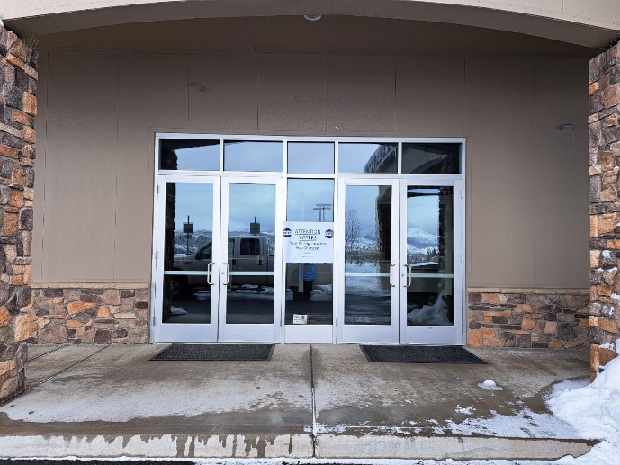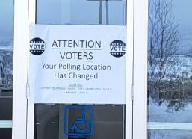
Voting Precincts that were located at the Community Church of Susanville,
on Numa Road have been moved to the Annex behind the
Historic Courthouse at 220 South Lassen Street, Susanville.
To Vote Please Visit:
HISTORIC COURTHOUSE ANNEX at 220 SOUTH LASSEN STREET, SUITE 5
SUSANVILLE, CA 96130
Questions? Call 530.251.8217

